JDK (Java development kit)

JDK is a software development kit that offers tools and libraries used for developing Java applications, it has different development tools like compilers and Java documents.

JRE (Java runtime environment)

JRE is a software package that provides Java class libraries, Java virtual machines, and other components to run Java applications.

JVM (Java virtual machine)

JVM is an abstract machine that enables your computer to run a Java program, what it does is to translate bytecode into native machine code for them to be directly executed.

Following is the illustration of the main difference between the three elements:

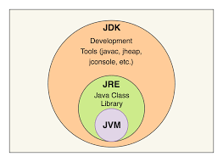  
 Figure1: (Redirect Notice, 2021)

Reference:

Google.com. 2021. *Redirect Notice*. [online] Available at: <https://www.google.com/url?sa=i&url=https%3A%2F%2Fmedium.com%2F%40choudajharshata%2Fdifference-between-jdk-jre-and-jvm-189a786e2855&psig=AOvVaw1OEyRx1yNeMTSzv1wxs48g&ust=1610797523679000&source=images&cd=vfe&ved=0CAIQjRxqFwoTCOD-9MTune4CFQAAAAAdAAAAABAN> [Accessed 15 January 2021].